AWS Site-to-Site VPN - Documentation

Modern organizations often run their infrastructure in multiple environments:
- Some resources remain in the company’s on-premises data center
- Some resources are hosted in AWS Cloud
These environments need secure communication for:
- applications
- databases
- authentication services
- internal business systems
Direct communication over the public internet is insecure.
To solve this problem, AWS provides:
Site-to-Site VPN
AWS Site-to-Site VPN creates a secure and encrypted connection between an on-premises network and an AWS Virtual Private Cloud (VPC) using the public internet.

What is a VPN?
VPN stands for:
Virtual Private Network
A VPN creates a secure communication tunnel between two networks over the internet.
The tunnel:
- encrypts traffic
- protects data from unauthorized access
- securely transfers information between networks
Even though traffic travels through the public internet, encryption ensures confidentiality and security.

Real-World Example
Consider a company with:
- an office network
- applications running in AWS
The office employees need secure access to applications hosted inside AWS.
Instead of exposing applications publicly:
- the company establishes a Site-to-Site VPN
- traffic becomes encrypted
- communication remains private

AWS Site-to-Site VPN Architecture
On-Premises Network
(192.168.1.0/24)
|
|
Customer Gateway (CGW)
|
=========================
Encrypted IPsec Tunnel
=========================
|
Virtual Private Gateway (VGW)
|
AWS VPC
(10.0.0.0/16)

Components of AWS Site-to-Site VPN
AWS Site-to-Site VPN consists of multiple components working together.

1. Virtual Private Cloud (VPC)
A VPC is a private virtual network in AWS where cloud resources are deployed.
Resources inside the VPC may include:
- EC2 instances
- databases
- containers
- application servers
Example:
VPC CIDR: 10.0.0.0/16

2. Customer Gateway (CGW)
The Customer Gateway represents the on-premises side of the VPN connection.
It is typically:
- a physical router
- firewall
- VPN appliance
Examples:
- Cisco Router
- Fortinet Firewall
- Palo Alto Firewall
- Juniper Router
In AWS, a Customer Gateway resource stores:
- public IP address of the on-premises device
- routing information
- BGP ASN information
Purpose of CGW:
- establishes VPN tunnel with AWS
- encrypts outgoing traffic
- decrypts incoming traffic

3. Virtual Private Gateway (VGW)
A Virtual Private Gateway is the AWS-side VPN endpoint attached to a VPC.
Purpose of VGW:
- receives VPN traffic
- decrypts encrypted packets
- forwards traffic into VPC
- sends VPC traffic back through VPN
The VGW acts as:
AWS-managed VPN router
Without a VGW:
- the VPC cannot participate in VPN communication

4. VPN Connection
The VPN connection is the encrypted communication tunnel between:
- Customer Gateway (CGW)
- Virtual Private Gateway (VGW)
The VPN connection:
- uses IPsec encryption
- securely transfers traffic
- supports routing between networks
AWS automatically creates:
Two VPN tunnels
Purpose:
- high availability
- redundancy
- failover support
If one tunnel fails, traffic continues through the second tunnel.

What is IPsec?
IPsec stands for:
Internet Protocol Security
IPsec is the security protocol used by AWS Site-to-Site VPN.
It secures communication by providing:
- encryption
- authentication
- integrity

Functions of IPsec
1. Encryption
Encryption converts readable data into unreadable encrypted format.
Example:
Original Data:
username=admin
password=hello123
Encrypted Data:
ajshd8272jsjs72js
This prevents attackers from reading intercepted traffic.

2. Authentication
Authentication ensures:
- both VPN endpoints verify each other’s identity
This prevents unauthorized systems from joining the VPN tunnel.

3. Integrity
Integrity ensures:
- data is not modified during transmission
If packets are altered:
- IPsec detects tampering

How Site-to-Site VPN Works

Step 1 – Packet Creation
An on-premises server creates a packet:
Source: 192.168.1.10
Destination: 10.0.1.25

Step 2 – Route Lookup
The on-premises router checks routing table:
10.0.0.0/16 → VPN Tunnel

Step 3 – Encryption
The Customer Gateway encrypts the packet using IPsec.

Step 4 – Tunnel Transmission
Encrypted traffic travels securely through the public internet.

Step 5 – AWS Receives Packet
The Virtual Private Gateway receives encrypted traffic.

Step 6 – Decryption
VGW decrypts the packet.

Step 7 – Traffic Forwarding
Traffic is forwarded inside the AWS VPC.

Routing in Site-to-Site VPN
Routing determines:
which traffic should enter the VPN tunnel
Example:
On-premises router:
10.0.0.0/16 → VPN Tunnel
AWS route table:
192.168.1.0/24 → Virtual Private Gateway
Without correct routing:
- communication fails

Types of Routing

1. Static Routing
Routes are manually configured.
Example:
192.168.1.0/24
Advantages:
- simple setup
Disadvantages:
- not scalable
- manual maintenance required

2. Dynamic Routing (BGP)
Uses:
Border Gateway Protocol (BGP)
Routers automatically exchange route information.
Advantages:
- scalable
- automatic failover
- automatic route learning
Most enterprise environments use BGP.

Difference Between Site-to-Site VPN and Direct Connect
Feature | Site-to-Site VPN | AWS Direct Connect
Connectivity | Public Internet | Dedicated Private Link
Security | IPsec Encryption | Private Physical Connection
Cost | Lower | Higher
Setup Time | Fast | Longer
Performance | Internet Dependent | Stable and Consistent

AWS Site-to-Site VPN Implementation Using StrongSwan (Lab Setup)
Objective
To implement a real-time AWS Site-to-Site VPN connection by simulating an On-Premises environment using another AWS VPC and configuring IPSec VPN connectivity using StrongSwan.

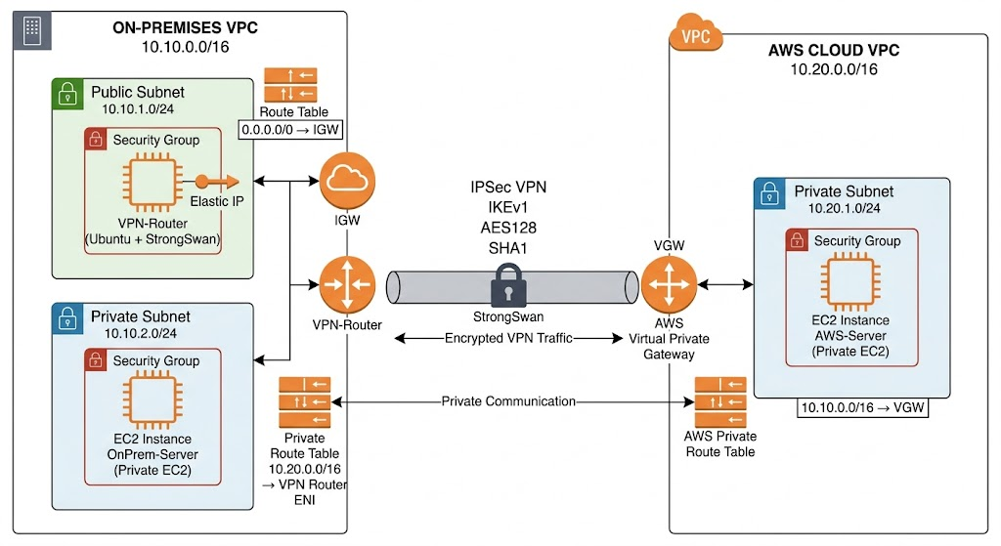

Components Used
Component | Purpose
AWS VPC | Simulates AWS cloud environment
OnPrem VPC | Simulates On-Premises datacenter
Virtual Private Gateway (VGW) | AWS VPN endpoint
Customer Gateway (CGW) | Represents OnPrem VPN Router
StrongSwan | IPSec VPN software
Elastic IP | Static public IP for VPN Router
Security Groups | Traffic control
Route Tables | Network routing

Network Configuration
Resource | CIDR
OnPrem-VPC | 10.10.0.0/16
OnPrem Public Subnet | 10.10.1.0/24
OnPrem Private Subnet | 10.10.2.0/24
AWS-VPC | 10.20.0.0/16
AWS Private Subnet | 10.20.1.0/24

Implementation Steps
1. Created On-Premises VPC
Created:
- OnPrem-VPC
- Public Subnet
- Private Subnet
- Internet Gateway
- Route Tables
Public Route Table
Destination | Target
0.0.0.0/0 | IGW
Associated with:
- OnPrem Public Subnet
Private Route Table
Initially no internet route added.
Associated with:
- OnPrem Private Subnet

2. Created AWS VPC
Created:
- AWS-VPC
- AWS Private Subnet
- AWS Private Route Table
No Internet Gateway attached to AWS-VPC to maintain private architecture.

3. Security Groups Configuration
VPN-Router-SG
Inbound Rules:
Type | Port | Source
SSH | 22 | My IP
UDP | 500 | 0.0.0.0/0
UDP | 4500 | 0.0.0.0/0
ICMP | All | 0.0.0.0/0

OnPrem-Private-SG
Type | Source
ICMP | 10.20.0.0/16
SSH | 10.10.0.0/16

AWS-Private-SG
Type | Source
ICMP | 10.10.0.0/16
SSH | 10.10.0.0/16

4. EC2 Instances Created
VPN-Router
Configuration | Value
AMI | Ubuntu 22.04
Subnet | OnPrem Public Subnet
Elastic IP | Attached
Security Group | VPN-Router-SG
Important Configurations
- Disabled Source/Destination Check
- Installed StrongSwan
- Enabled IP forwarding

OnPrem-Server
Configuration | Value
AMI | Amazon Linux
Subnet | OnPrem Private Subnet
Public IP | Disabled
Security Group | OnPrem-Private-SG

AWS-Server
Configuration | Value
AMI | Amazon Linux
Subnet | AWS Private Subnet
Public IP | Disabled
Security Group | AWS-Private-SG

5. Virtual Private Gateway (VGW)
Created:
- AWS-VGW
Attached to:
- AWS-VPC
Purpose:
- AWS side VPN endpoint.

6. Customer Gateway (CGW)
Created:
- OnPrem-CGW
Configuration:
Parameter | Value
Routing | Static
Public IP | Elastic IP of VPN Router
ASN | 65000
Purpose:
- Represents OnPrem VPN Router in AWS.

7. Site-to-Site VPN Connection
Created Site-to-Site VPN using:
Parameter | Value
Target Gateway | VGW
Customer Gateway | Existing CGW
Routing | Static
Static Route Added:
10.10.0.0/16

8. Downloaded VPN Configuration
Downloaded AWS VPN configuration using:
- Vendor: Generic
- Software: StrongSwan
Configuration contained:
- Tunnel Outside IPs
- PSK Keys
- IKE Policies
- IPSec Policies

9. StrongSwan Installation and Configuration
Installed:
sudo apt install strongswan strongswan-starter -y
Enabled IP forwarding:
net.ipv4.ip_forward=1
Verified:
sysctl net.ipv4.ip_forward

ipsec.conf Configuration
Configured:
- Tunnel parameters
- IKEv1
- AES128 encryption
- SHA1 hashing
- MODP1024 DH Group

ipsec.secrets Configuration
Configured PSK provided by AWS.
Example:
98.83.216.97 34.206.111.149 : PSK "xxxxxxxx"

10. Tunnel Verification
Verified using:
sudo ipsec statusall
Tunnel Status:
ESTABLISHED
INSTALLED, TUNNEL
Verified:
- IKE Phase 1 successful
- IPSec Phase 2 successful
- Encryption operational

11. Route Table Configuration
AWS Route Table
Added:
Destination | Target
10.10.0.0/16 | VGW

OnPrem Private Route Table
Added:
Destination | Target
10.20.0.0/16 | VPN Router ENI

Troubleshooting Performed
Validated:
- IPSec tunnel status
- Security Group rules
- Route Tables
- NACL rules
- Source/Destination Check
- ICMP traffic
- StrongSwan logs
Used commands:
sudo ipsec statusall
sudo journalctl -u strongswan-starter
sudo tcpdump -i any icmp

Current Status
Component | Status
IPSec Tunnel | SUCCESSFUL
VPN Connectivity | ESTABLISHED
AWS VGW Integration | SUCCESSFUL
StrongSwan Configuration | SUCCESSFUL
Routing Configuration | COMPLETED
End-to-End Ping | Under Final Validation

Key Learnings
- Understanding AWS Site-to-Site VPN architecture
- IPSec tunnel establishment
- Role of VGW and CGW
- StrongSwan VPN configuration
- Static routing implementation
- Security Group and NACL troubleshooting
- Hybrid cloud networking concepts

Conclusion
Successfully implemented a real-time AWS Site-to-Site VPN lab environment using StrongSwan by simulating an On-Premises network with another VPC. Established IPSec tunnel connectivity between AWS Virtual Private Gateway and Customer Gateway with proper routing and security configurations. Gained hands-on experience in hybrid cloud networking and VPN troubleshooting.

